GovDev for TFS: User Guide

The GovDev for TFS process template is put together with Public Sector in mind. The template is based on the MSF Agile template with elements from the MSF CMMI template and a well-defined process flow. It is designed to address the needs of Public Sector software development teams that have:

* Software Planning & Delivery that is rigid and based on a gated Waterfall process.
* Software Development Teams desire for Agile process but Planning & Delivery does not match.

As a result of the nature of Public Sector software development, the template also looks to address secondary problems of:

* Due to Waterfall roots, artifacts like “Requirements Traceability Matrix” are highly requested.
* Public Sector projects highly leverage contractors and Program\Project Managers need ways to measure their work effort.

This guide sets out the different artifacts added to the template and how to use them.

Requirements



UC

UC

UC

Tasks

Tasks

Tasks

Tests

Tests

Bugs

Bugs

Bugs

Tests

# New Work Items

## Use Case with Scenarios

The Use Case with Scenarios provides the main integration point between Waterfall Requirements and Agile tasks. Software teams will use the Use Case as the iteration backlog element for work. All Task, Test Case and Bug work items can be linked t a Use Case for management and traceability.

## Support Ticket

The support ticket work item has been added to help integrate the Operations team into the use of TFS. A complete article on its intended use can be found in MSDN magazine here (<http://msdn.microsoft.com/en-us/magazine/hh335060.aspx>).

# New Reports

## Requirements Traceability

This new report gives users the ability to see requirements and their associated tasks, test cases , bugs and code changesets in an expanding hierarchy. This allows tracing from a requirement all the way down to the set of code that implements it. For the report to display directly, work item links need to be made between each of the various work items in the process. Each work item is allowed to link only with other specific work items or artifacts in order to have a logical process flow. More can be found here (<http://msdn.microsoft.com/en-us/library/dd286694.aspx>) on linking work items.

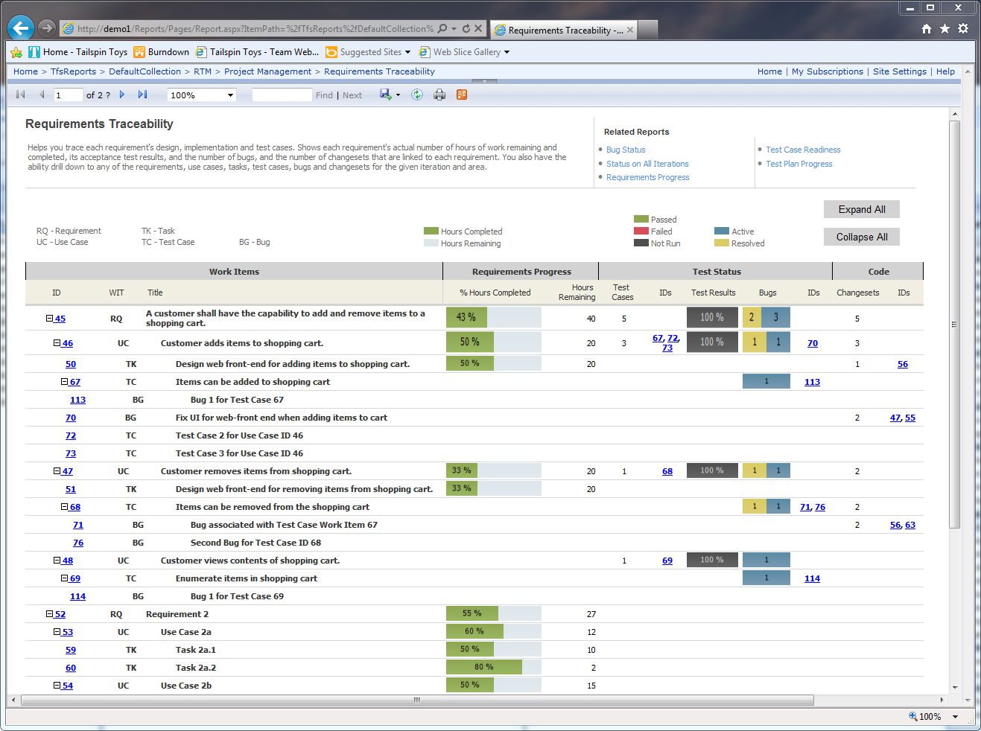

## Contribution by Team Member

This report allows high-level stakeholders to see the contributions by each team member. It looks at the completed hours on tasks by each team member, check-ins by team member, and how many lines of code they have added, deleted, and modified. It should be noted that the most lines added does not mean that team member contributed the most, as the quality of lines is what is most important.

